TEST
- Translate the words. / Переведи слова:
- Baker –
- Greengrocer –
- Mechanic –
- Postman –
- Waiter –
- Nurse –

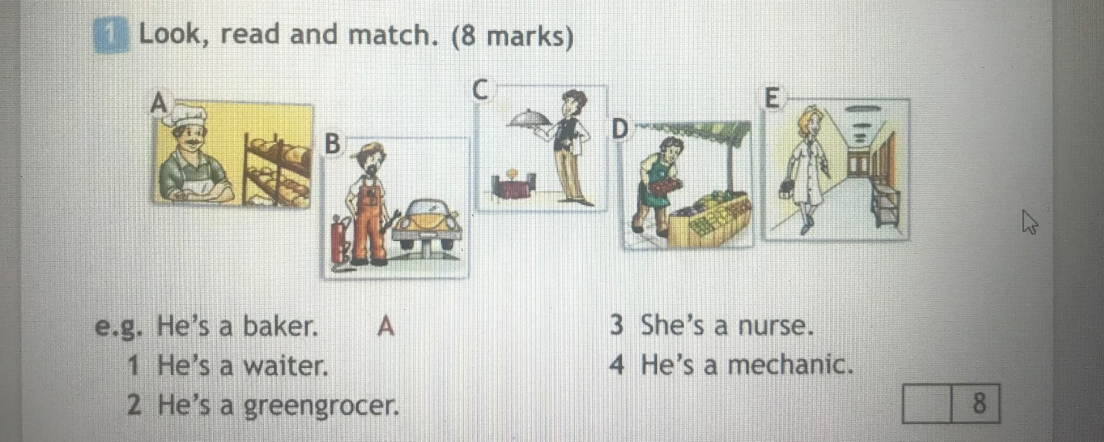
- Спиши текст:
My name is Danielle Pearson. I live in Wisconsin, USA. My school is called Danver Elementary School and I really like it there. School starts at 8.30. We have a break at 10.30, and most of the students go outside.
We have lunch every day at 12.15. I usually eat in the school canteen. In the afternoon we usually have Art, PE or Music. After school, at 3 o'clock, I go home and play with my little sister. Then I help my mother to cook dinner. After dinner I always do my homework and then I read or watch TV for a while. I go to bed every night at 10 o'clock.
__________________________________________________________________________________________________________________________________________________________________________________________________________________________________________________________________________________________________________________________________________________________________________________________________________________________________________________________________________________________________________________________________________________________________________________________________________________________________________________________________________________________________________________________________________________________________________________________________

