Задания для 3 класса
HOMEWORK
Exercise 1. Colour the balloons:
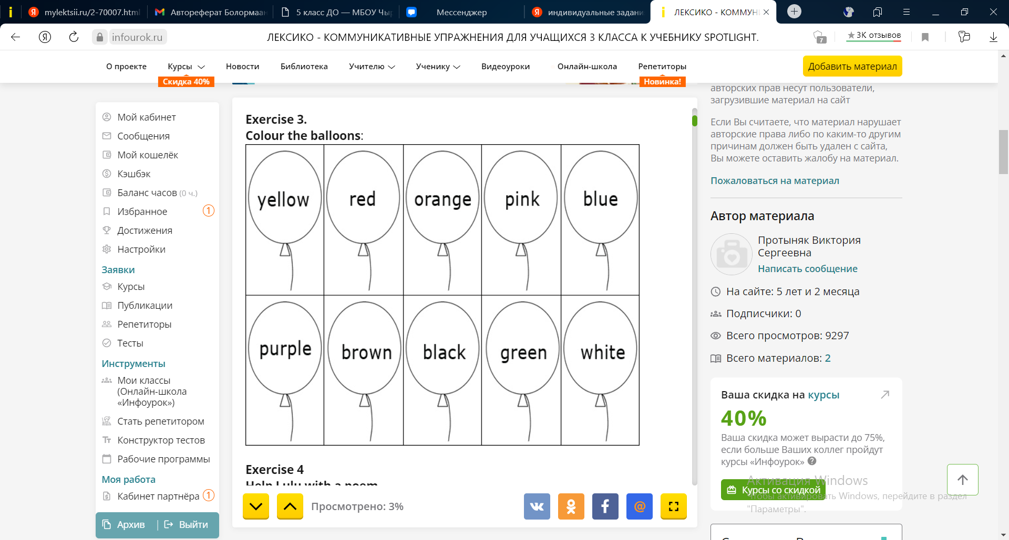
Exercise 2. Write the numbers: 2 two
17 …………………………. 16 ……………………….19 ……………………….
11 …………………………. 14 ……………………….12 ……………………….
13 …………………………. 20 ….…………………….5………………………….
Exercise 3. Underline the correct word.
This is \ are my sister. She is \ are a little girl.
They is \ are good friends. My sister and brother is \ are in the room.
We is \ are a happy family. My name is \ are Kevin.
Exercise 4. Read the words and find their meaning. Write the answers in the box:
1. Cheese a) паста (макаронные изделия)
2. Chicken b) рис
3. Egg с) картофель
4. Jelly d) морковь
5. Lemonade е) кока-кола
6. Cake f) лимонад
7. Carrot g) сыр
8. Pasta h) сосиска
9. Potatoes i) торт
10. rice j) яйцо
11. sausage k) желе
12. Coke l) курица
1 | 2 | 3 | 4 | 5 | 6 | 7 | 8 | 9 | 10 | 11 | 12
Exercise 5. Read and divide the words into groups:
Lemonade, jelly, banana, vegetable, water, cheese, egg, chicken, ice cream, orange juice, chocolate, pizza, sandwich, burger, chips, milk, apple.
Room: _________________________________________________________________
Drinks: ________________________________________________________________
Fruit: __________________________________________________________________
Desserts: _______________________________________________________________

